Only namespaces removal

Removing namespaces
Source/ZNA.UW.Web/Analysis/MultiLine/LossHistory/GetClaimHistory.ascx.cs
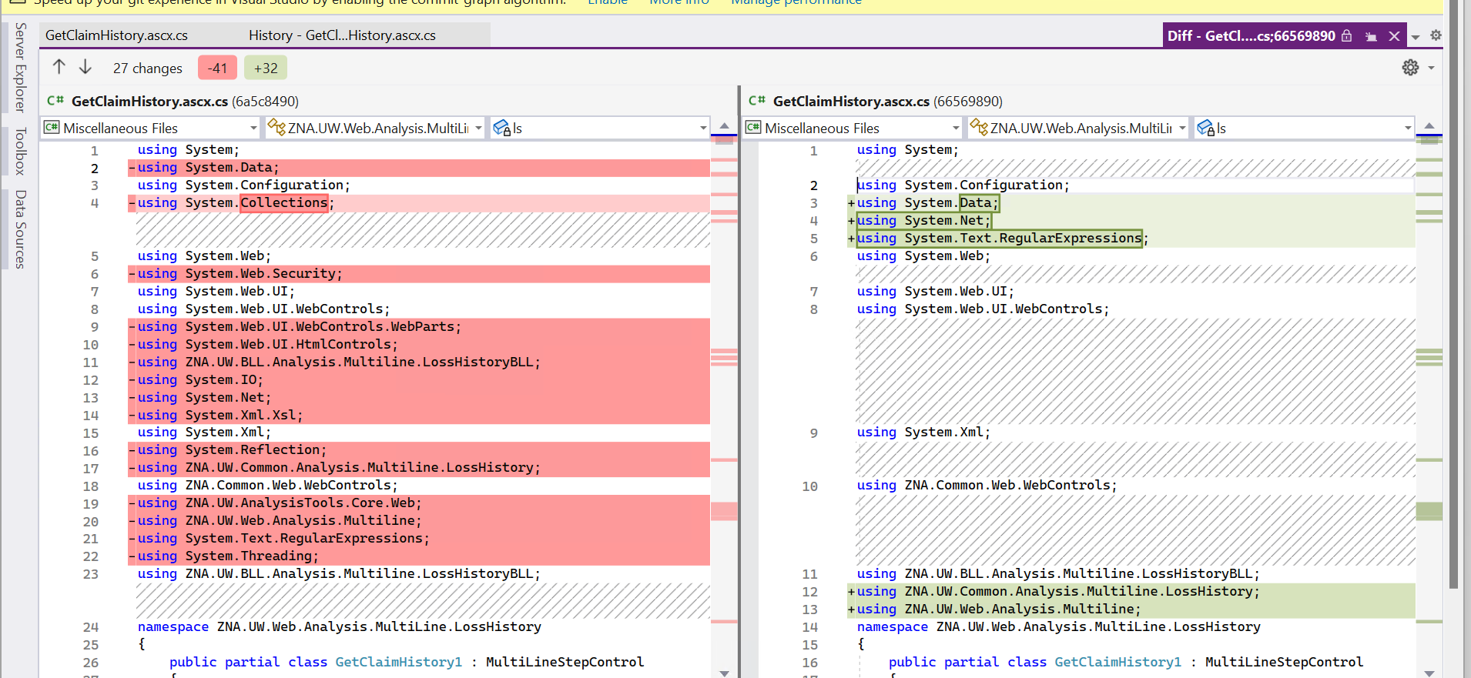

Removal and addition of namespaces
Source/ZNA.UW/ZNA.UW.BLL/Analysis/AUTO/NonOwnedAutoSX.cs
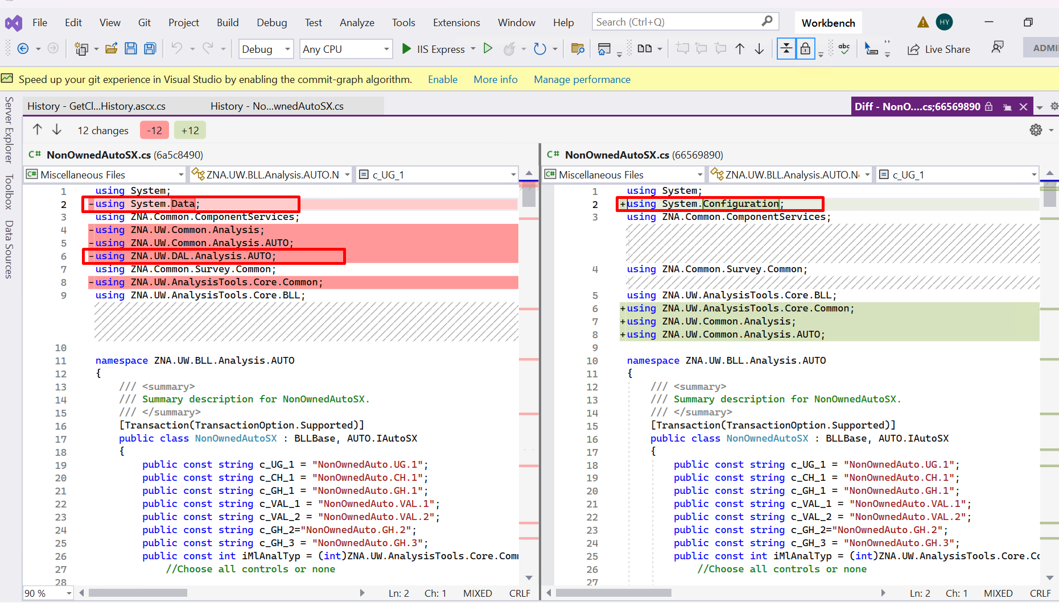
Removed the line
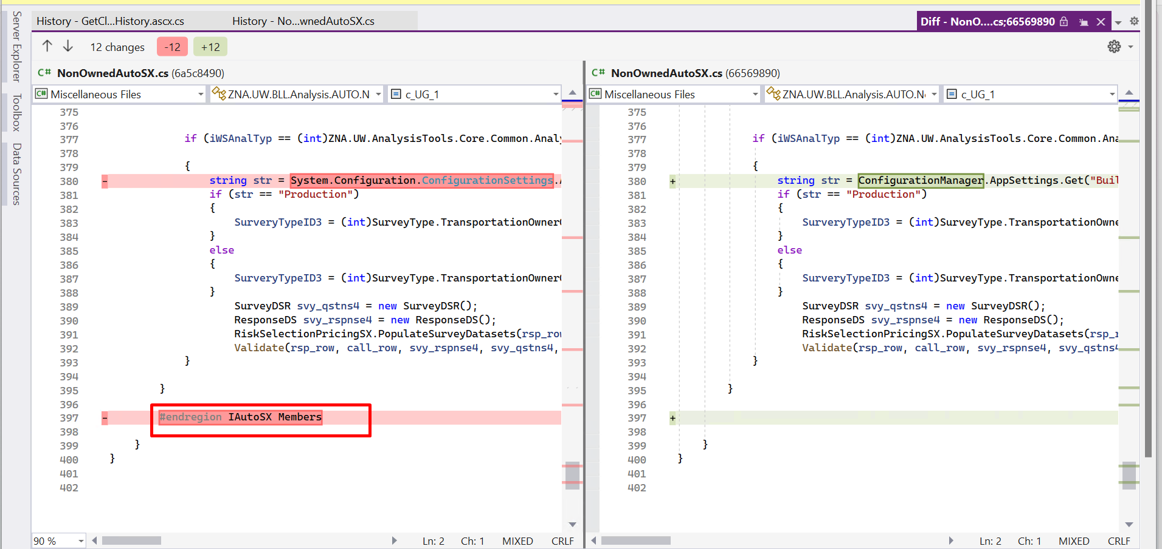
Remove of namespaces
Source/ZNA.UW/ZNA.UW.BLL/Analysis/Multiline/LossHistoryBLL/LossHistorySX.cs
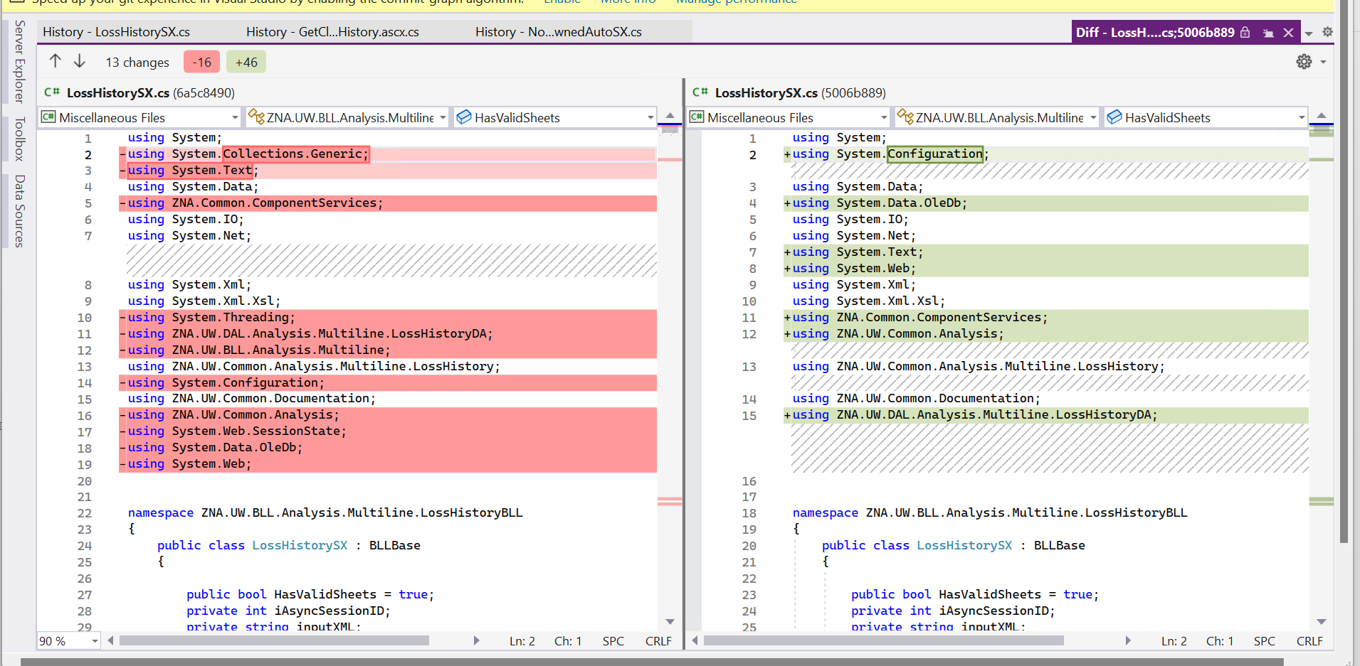

Removal of namepsaces
Source/ZNA.UW/ZNA.UW.BLL/Analysis/Multiline/SingleImport/SingleImportOptionListSX.cs
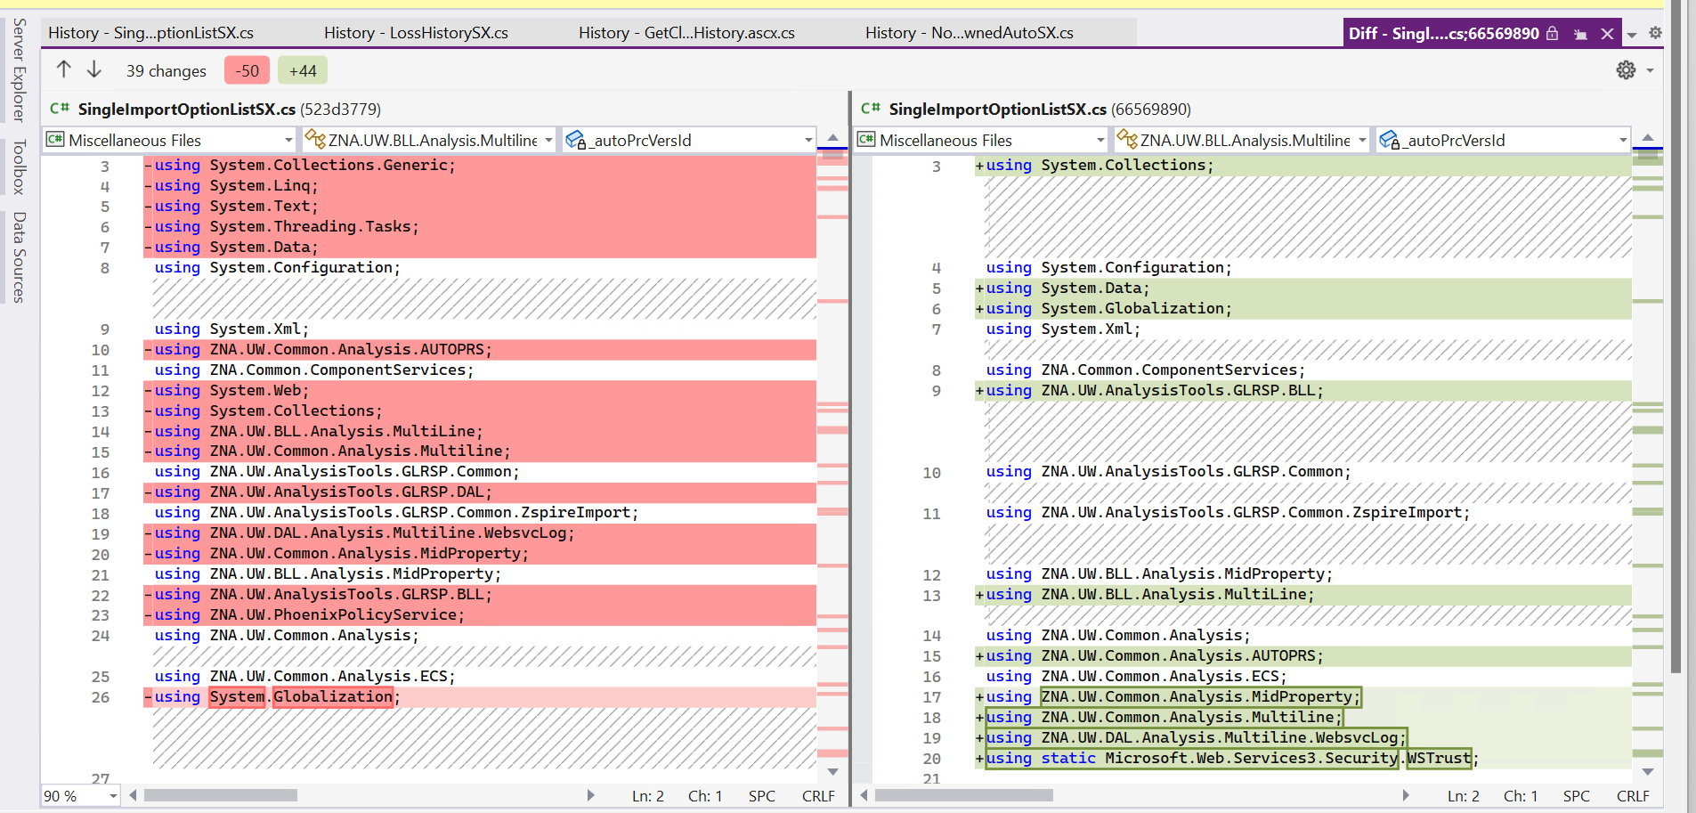

Source/ZNA.UW.AnalysisTools/GLRSP/Web/StepControls/HotTopics.ascx.cs
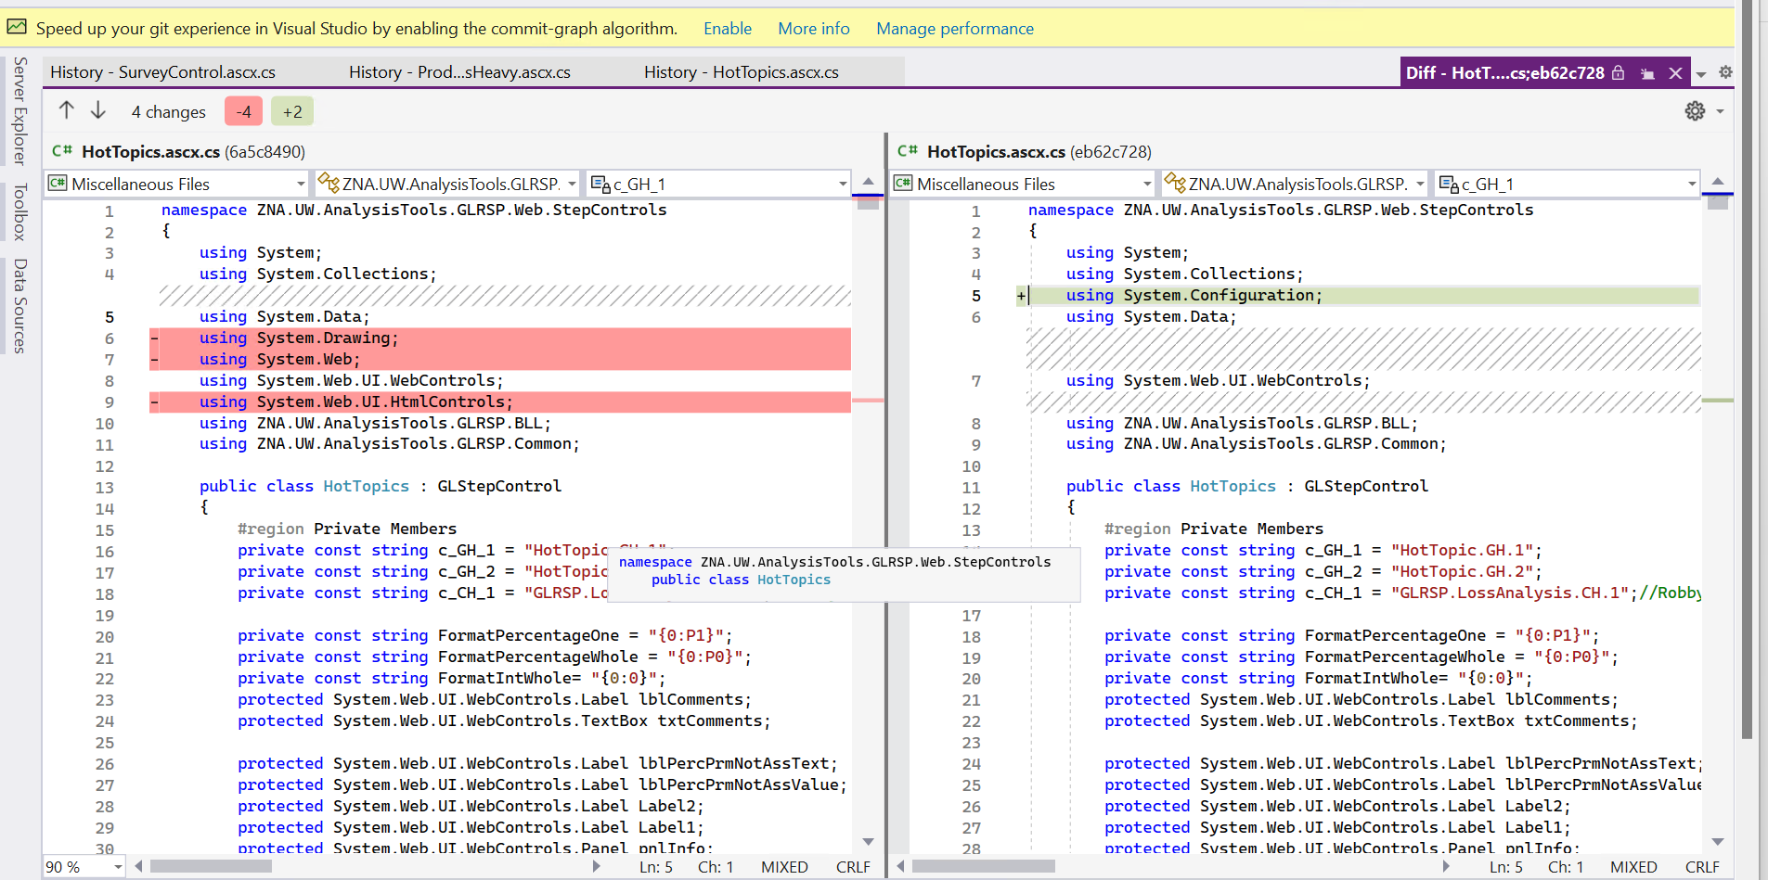
Source/ZNA.UW/ZNA.UW.BLL/Analysis/Multiline/AccountROE/AcctROESX.cs
